**Creating a Basic VPC and Associated Components**

Introduction

In this hands-on lab, we will create a VPC with an internet gateway, as well as create subnets across multiple Availability Zones.

Solution

Create a VPC

1. Navigate to the VPC dashboard.
2. Click **Your VPCs** in the left-hand menu.
3. Click **Create VPC**, and set the following values:
   * *Name tag*: **VPC1**
   * *IPv4 CIDR block*: **172.16.0.0/16**
4. Leave the *IVv6 CIDR block* and *Tenancy* fields as their default values.
5. Click **Create**.

Create a Public and Private Subnet in Different Availability Zones

Create Public Subnet

1. Click **Subnets** in the left-hand menu.
2. Click **Create subnet**, and set the following values:
   * *Name tag*: **Public**
   * *VPC*: **VPC1**
   * *Availability Zone*: **us-east-1a**
   * *IPv4 CIDR block*: **172.16.1.0/24**
3. Click **Create**.

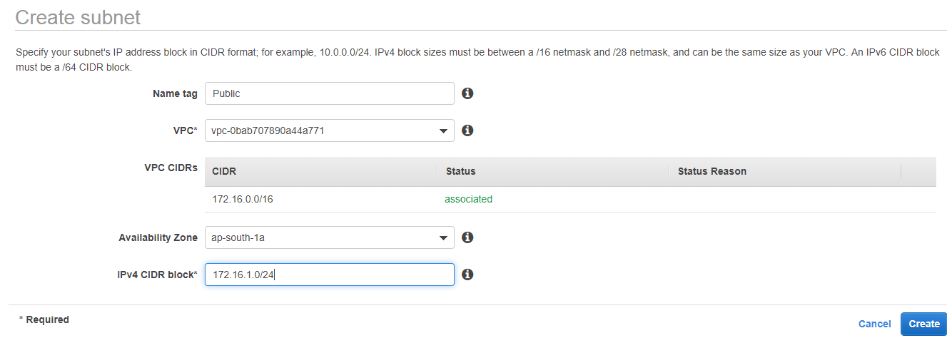

Create Private Subnet

1. Click **Create subnet**, and set the following values:
   * *Name tag*: **Private**
   * *VPC*: **VPC1**
   * *Availability Zone*: **us-east-1a**
   * *IPv4 CIDR block*: **172.16.2.0/24**
2. Click **Create**.

Create an Internet Gateway, and Connect It to the VPC

1. Click **Internet Gateways** in the left-hand menu.
2. Click **Create internet gateway**.
3. Give it a *Name tag* of "IGW".
4. Click **Create**.
5. Once it's created, click **Actions** > **Attach to VPC**.
6. In the dropdown, select our **VPC1**.
7. Click **Attach**.

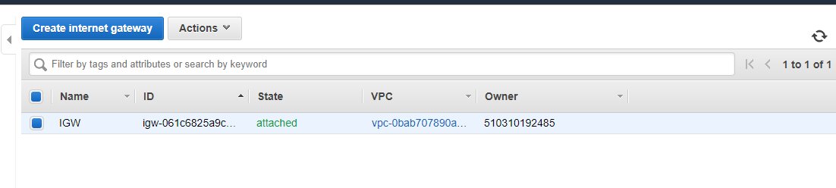

Create Two Route Tables, and Associate Them with the Correct Subnet

Create and Configure Public Route Table

1. Click **Route Tables** in the left-hand menu.
2. Click **Create route table**, and set the following values:
   * *Name tag*: **PublicRT**
   * *VPC*: **VPC1**
3. Click **Create**.
4. With *PublicRT* selected, click the **Routes** tab on the page.
5. Click **Edit routes**.
6. Click **Add route**, and set the following values. Remember to take destination as your internet gateway.

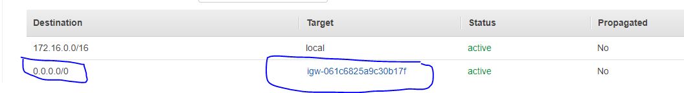

1. Click the subnet association and edit it.
2. Select the public subnet and add it to your route table.

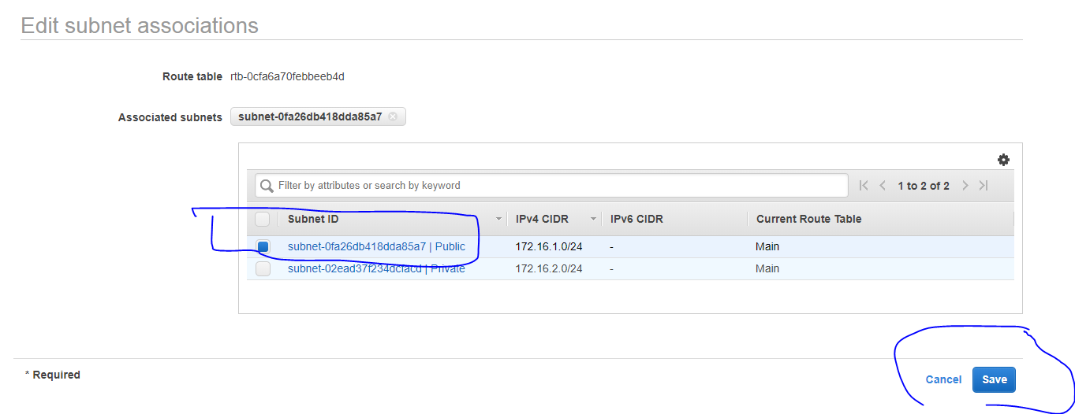

Now you can create your VPC in public subnet and it should work.

